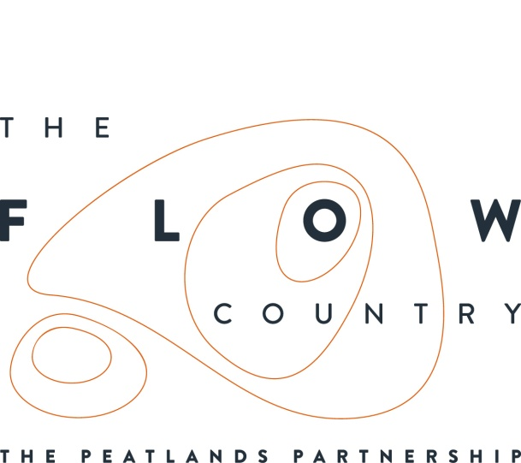

Press Release: 16th January 2018

2017 – Another great year for the Flow Country

LAST year saw an eclectic range of activities and events come together to promote the Flow Country and help with its restoration at Forsinard and across Sutherland and Caithness.

The Flow Country touring exhibition was launched in June at the Royal Botanical Garden in Edinburgh at an event attended by politicians, artists, scientists and others. Graeme Dey MSP, Convenor of the Scottish Parliament’s Scottish Parliament’s Environment, Climate Change and Land Reform Committee was one of our guests of honour.

In January 2017, Flows to the Future staff worked with Peter’s Pals young curators club at Caithness Horizons, Thurso, to produce artwork to compliment the upcoming new Flow Country exhibition.

February saw a residential study group visiting from Edinburgh College of Art when postgraduate students learned about the Flows landscape and gained inspiration for their work.

In March, the Flow Country conference took place, organised by the Environmental Research Institute in Thurso. Dedicated to peatland research in the Flow Country, the theme of the conference was ‘thinking big’, with updates on research projects and new findings. There was also a special session on remote sensing and other approaches needed to measure processes and communities over large scales.

Also in March, the Flow Country film was shown at the Wild Film Festival Scotland in Dumfries and Galloway.

The Flow Country restoration project gained thousands of worldwide public votes in a European Outdoor Conservation Association (EOCA) competition for grant-funding conservation projects around the world. The public vote was followed by an EOCA members vote that resulted in the Flow Country project gaining a grant award of almost €30,000 (Euro). Everyone involved with the work is delighted with this great outcome.

March also saw Learning Development Officer Sjoerd Tel lead Caithness Science Festival sessions at seven schools, focussing on bog bodies. Former Communities Officer Jenny Middlehurst also hosted an activity at the popular science festival family fun day.

April saw the Pathways to Poetry workshop led by award-winning writer and poet Laura Morgan at Timespan, Helmsdale, which inspired extracts for the Flow Country calendar. There was also a nature’s Easter crafts event at Caithness Horizons.

April also marked the beginning of artists’ residencies for Hannah Imlach and Shaun Fraser, and the Flows to the Future Project hosted cross discipline workshop bringing together arts organisations and scientists, to promote more artistic activity in the area. In May, STV News aired a short feature about the Flow Country and the work of the artists in residence (Hannah Imlach and Shaun Fraser).

In June, award-winning artist Magi Sinclair led a “Pencilling the Peatlands” workshop at the field centre. Some of the artwork was used in the 2018 Flow Country calendar.

During that month we also held a tourism training event at Forsinard for people involved with the tourism industry in Caithness and Sutherland.

There was also an evening of storytelling and music led by Alexandria Patience and Irene Macleod at Strathnaver Museum to celebrate the new Flow Country interpretation there.

Also in June, an exhibition was held at Timespan of crafts made by local children in school sessions with Sjoerd Tel and photographs by the Thurso Camera Club.

July saw a Future Shapers event, which was a residential week for young people who enjoyed events and made new friends while learning about the Flow Country and taking the opportunity to learn how to shape the future, both locally and globally.

Cabinet Secretary for Environment, Climate Change and Land Reform, Roseanna Cunningham MSP visited the Flow Country and officially opened the Flows Field Centre in August.

A new Flow Country exhibition was launched at Caithness Horizons with a day of activities to celebrate.

There was also an event at Forsinard Flows National Nature Reserve bringing together Scotland’s Natural Larder and Feis Rois, complete with live music at the Flows Lookout. This also launched completed new displays within the Forsinard Flows visitor centre.

A visit from Gail Ross MSP gave us the opportunity to share details of our work with another politician who has a passion for conservation. Gail was very impressed by the work being done in the Flow Country and made suggestions for future events that could highlight this work.

The first of four working holiday weeks was held at RSPB Forsinard. People from around the country enjoyed a week packed with activities to give them a memorable experience of the Flow Country and help with its conservation.

In September, the Flow Country touring exhibition moved to the Glasgow Science Centre and a series of talks were held at Forsinard to coincide with another working holiday. This year has seen a big increase in volunteering, including many more local volunteers.

October saw a highly successful dark sky event facilitated by Caithness Astronomy Group at the Field Centre. Despite some inclement weather, the event proved to be very popular. Also in October, new Communities Officer, Jonathan Ford, started work.

In November, local contractor John Mackay won an RSPB innovation award for pioneering development and operation of specialised machinery to work on fragile peatland sites in the Flow Country. His award was commended in the Scottish Parliament. Johnny Mackay’s work is just part of the large scale restoration work that has been going on this year, removing non-native trees that have been planted on deep peat and blocking up the drainage ditches.

In the closing month of 2017, Sjoerd Tel held festive Christmas tree events at ten schools to help the children find out more about peatland restoration, and the Flows to the Future project sent a 2018 calendar to every household in Caithness and Sutherland. The calendar featured artwork and content from events held throughout the year. The project also issued its second annual newsletter.

Caroline Eccles, Project Manager, said “this has been a great opportunity to look back over 2017 and see just how much was happening during the year. 2017 was the year where we took the Flow Country to people out of the local area, but we are also really proud of our many successful events around Caithness and Sutherland. We’re particularly glad that so many people are getting involved. I’m looking forward to 2018, which is shaping up to be another very busy year for the Flow Country, including new venues for our Touring Exhibition, and many more inspiring activities and events.”

ENDS

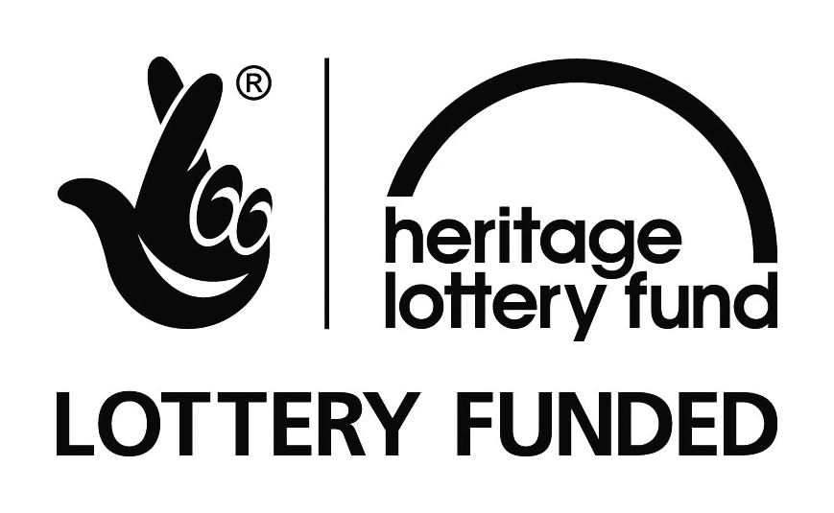

NOTES TO EDITORS
The Peatlands Partnership includes Scottish Natural Heritage, Forestry Commission (Scotland), Highland Council, RSPB Scotland, Plantlife Scotland, Highlands & Islands Enterprise, The Highland Third Sector Interface, The Flow Country Rivers Trust, The Northern Deer Management Group and The Environmental Research Institute. It liaises with local community groups, , the Scottish Government’s Rural Payments and Inspections Directorate and the North Sutherland Community Forest Trust. It is chaired by Professor Stuart Gibb from the Environmental Research Institute.
RSPB Scotland is the lead partner in The Flows to the Future project, a Peatlands Partnership project, which gratefully acknowledges funding from the Heritage Lottery Fund and from the following funders and supporters; Environmental Research Institute, European Regional Development Fund, Forestry Commission (Scotland), Peatland Action, Highlands and Islands Enterprise, The Highland Council, RSPB, WREN, Scotland Rural Development Programme, Scottish Government, Scottish Natural Heritage and The Tubney Trust.

CONTACT DETAILS
Caroline Eccles Project Manager - Flows to the Future Project, working on behalf of The Peatlands Partnership, c/o North Scotland Regional Office, Inverness. 01463 715000, Mobile 07590 441475 or caroline.eccles@rspb.org.uk
Ian Mitchell, Secretary, The Peatlands Partnership, c/o Scottish Natural Heritage: Tel 01408 634063 or peatlands_partnership@snh.gov.uk

