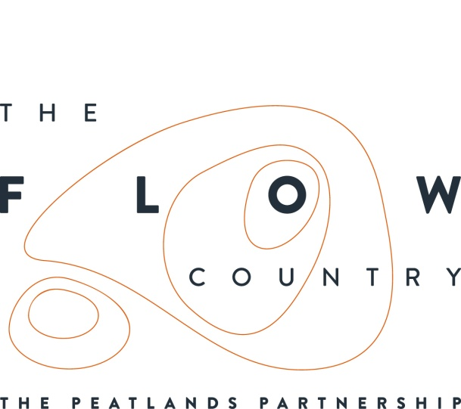

Press Release: 24/03/2017

Submissions now open for 2018 calendar inspired by the Flow Country.

The Flows to the Future Project is now accepting submissions for a 2018 Flow Country calendar.

Submissions for the calendar should be related to or inspired by The Flow Country
peatlands and all forms of visual art are welcome, such as drawing, painting and
photography. The deadline for submissions is the 31st July 2017.

Successful candidates will have their work displayed in the calendar. It is hoped that entries will cover all facets of the Flow Country peatlands, from the landscape and wildlife of this internationally important habitat, to the people who live and work there. A copy of the calendar will be distributed to all households within Caithness and Sutherland free of charge.

As well as this open call for submissions, there will also be a number of events to generate material for the calendar. The first event is Pathways to Poetry, a poetry Workshop with award winning writer and poet Laura Morgan, which will develop words to complement the calendar images. This will be held at Timespan, Helmsdale on the 8th April, 10.30am – 1pm and will include a short walk and exercises to help stimulate creative thinking. Booking is essential, contact Jenny, Communities Officer on 01641 761312 or jenny.middlehurst@rspb.org.uk.

The calendar could provide a sponsorship opportunity for a local business. If your organisation would like to have its logo seen by all households in Caithness and Sutherland please get in touch with Jenny, Communities Officer.

More details about these activities and others coming up can be found on the Flow Country website events page, www.theflowcountry.org.uk , along with lots of information and inspiration about peatlands. The Flows to the Future Project, a Heritage Lottery funded project is restoring areas of blanket bog in the heart of the Flow Country that have been damaged by forestry planting, as well as enabling more people to find out about and be inspired by the area. It is a Peatlands Partnership initiative for which RSPB Scotland is the lead partner.

PHOTOGRAPH:
Painting of Bog Cotton by Katy Kitchingham.

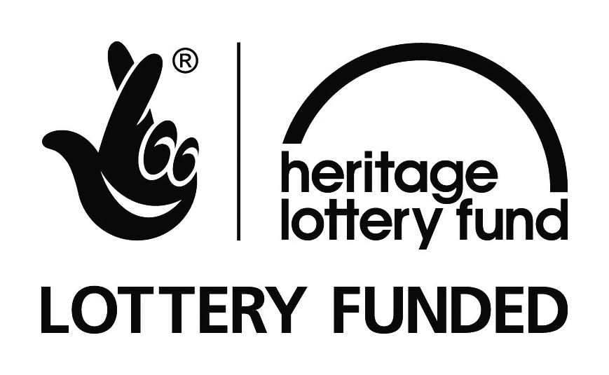

NOTES TO EDITORS
The Peatlands Partnership includes Scottish Natural Heritage, Forestry Commission (Scotland), Highland Council, RSPB Scotland, Plantlife Scotland, Highlands & Islands Enterprise, The Highland Third Sector Interface, The Flow Country Rivers Trust, The Northern Deer Management Group and The Environmental Research Institute. It liaises with local community groups, , the Scottish Government’s Rural Payments and Inspections Directorate and the North Sutherland Community Forest Trust. It is independently chaired by John Henderson of Scrabster Farm, Caithness.
RSPB Scotland is the lead partner in The Flows to the Future project, a Peatlands Partnership project, which gratefully acknowledges funding from the Heritage Lottery Fund and from the following funders and supporters; Environmental Research Institute, European Regional Development Fund, Forestry Commission (Scotland), Peatland Action, Highlands and Islands Enterprise, The Highland Council, RSPB, WREN, Scotland Rural Development Programme, Scottish Government, Scottish Natural Heritage and The Tubney Trust.

CONTACT DETAILS
Alan Tissiman RSPB Public Affairs Manager can be contacted on 01463 228810 or 07775 227614 or alan.tissiman@rspb.org.uk
Caroline Eccles Project Manager - Flows to the Future Project, working on behalf of The Peatlands Partnership, c/o North Scotland Regional Office, Inverness. 01463 715000, Mobile 07590 441475 or caroline.eccles@rspb.org.uk
Ian Mitchell, Secretary, The Peatlands Partnership, c/o Scottish Natural Heritage: Tel 01408 634063 or peatlands_partnership@snh.gov.uk

