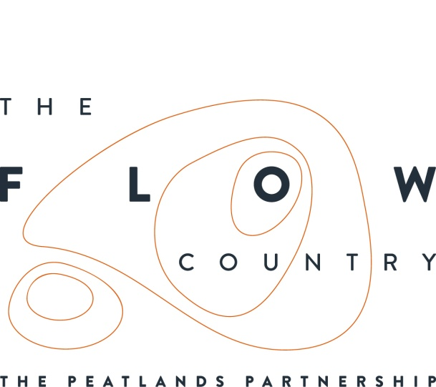

Press Release: August 2018

Volunteering thrives at Forsinard

This month marks the 7-year anniversary of long-time volunteer Paul Trebess’ time in the Flow Country. Since 2011, Paul has travelled by train to the Forsinard Flows RSPB nature reserve every Wednesday and Thursday throughout the Summer months and has built up quite a fan base of visitors, earning himself the nickname as the original ‘Vibrant Volunteer.’

On the aspect of volunteering that surprised him the most Paul said: ‘some visitors expect rare species on tap, and seem surprised that we don’t have black throated divers and eagles roaming the Visitors Centre!’

Paul went on to say that the best part of volunteering was ‘entertaining the visitors and meeting people from all over the world. (My) ancestors came from New Zealand, so it’s especially nice to meet people from New Zealand, of which there are a surprising amount!’

There are around 8 “local” volunteers who regularly volunteer at Forsinard, both with outdoor and indoor jobs. In addition, 5 residential interns live in the flat above the Flows Field Centre in Forsinard and are now over half way through their 7 months stay on the reserve. They come from all over the UK and one has come all the way from the United States to volunteer.

Sydney, the people engagement intern, was straight in at the deep end on her arrival in June, leading pond dipping for visiting school groups. She said ‘It was fantastic to see the excitement of the children at finding not only the (relatively) larger beasties like newts, but also their joy in finding the undeservedly less-appreciated diving beetles and midge larvae. Their excitement was certainly contagious.’
The four conservation skills interns get involved with a range of activities from wading in lochs sampling invertebrates, to raptor watches, to leading guided walks. Intern Harris, said that the aspect he enjoyed the most about volunteering was ‘being out and about and making new friends.’

The interns all live in a flat together and in their free time have been exploring Sutherland and Caithness, finding puffins and orcas (and eating lots of fish and chips). Sydney said ‘a really lovely part of the internship here is the location, and the wildlife that is so accessible to us. I’ve lived in cities my whole life, so being able to drive to the coast on the weekend and see nesting seabird colonies in such close proximity is amazing. Waking up in the morning to a deer right outside my window took a while to get used to though.’

Caroline Eccles, project manager said ‘we are so grateful for the help and support of our volunteers, we wouldn’t be able to carry out the work we do on the reserve and beyond without them.’

Volunteering at Forsinard has increased considerably since the creation of the new field centre funded by HLF and other partners. To get involved with volunteering yourself contact Claire Foot-Turner at Claire.foot@rspb.org.uk or see http://www.theflowcountry.org.uk/volunteering/
There is currently a vacancy for a residential people engagement volunteer from October and local volunteers are always very welcome.

Photos and captions.
- 4 interns
‘from left to right, Fairlie, Alice, Shen and Harris, the four conservation skills interns’

- Paul Trebess
‘Paul Trebess, long term local volunteer, ready to greet visitors to the RSPB flow reserve’

- Alice and Fairlie making bread’
‘Making bread in the intern kitchen’

- Fairly and Rob in the Lab
‘Intern, Fairlie, in the lab with Rob, the research assistant’

- Harris and orchid
‘Intern, Harris, with a spotted heath orchid,’

- Sydney and dogs
‘Although, not Flow Country creatures, intern Sydney, is very pleased to meet these two pups’

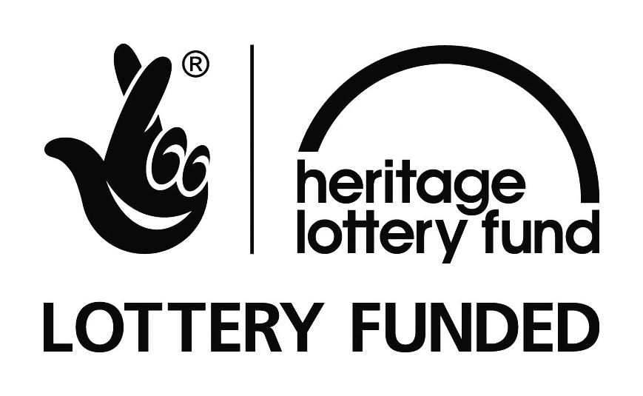

NOTES TO EDITORS
The Peatlands Partnership includes Scottish Natural Heritage, Forestry Commission Scotlandland Council, RSPB Scotland, Plantlife Scotland, Highlands & Islands Enterprise, The Highland Third Sector Interface, The Flow Country Rivers Trust, The Northern Deer Management Group and The Environmental Research Institute. It is chaired by Professor Stuart Gibb from the Environmental Research Institute.
RSPB Scotland is the lead partner in The Flows to the Future project, a Peatlands Partnership project, which gratefully acknowledges funding from the Heritage Lottery Fund and from the following funders and supporters; Environmental Research Institute, European Regional Development Fund, Forestry Commission (Scotland), Peatland Action, Highlands and Islands Enterprise, The Highland Council, RSPB, WREN, Scotland Rural Development Programme, Scottish Government, Scottish Natural Heritage and The Tubney Trust.

CONTACT DETAILS
Caroline Eccles Project Manager - Flows to the Future Project, working on behalf of The Peatlands Partnership, c/o The Flows Field Centre, Forsinard Mobile 07590 441475 or caroline.eccles@rspb.org.uk
Ian Mitchell, Secretary, The Peatlands Partnership, c/o Scottish Natural Heritage: Tel 01408 634063 or peatlands_partnership@snh.gov.uk

