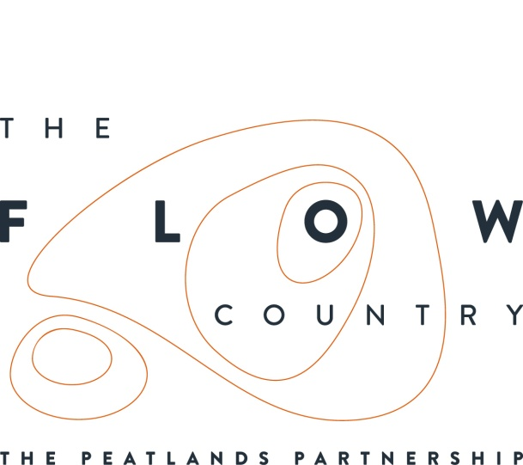

Press Release: July 2018

Limited Edition Golden Plover Pin Badges

A limited edition Golden Plover pin badge has been designed to honour this iconic Flow Country bird. The badge features a golden plover in its distinctive gold and black summer plumage and is available only from the Forsinard Flows Visitor Centre or from the RSPB national headquarters for a donation of £2.

Golden plovers are a type of wading bird and like flat, wet habitat, making the Flow Country a perfect place for them. The Flow Country is home to nationally important numbers of golden plovers. By buying a pin badge, not only will you be collecting a limited edition iconic piece, but will also help to fund the continued work of RSPB Scotland to look after the habitat of these beautiful birds.

A one-of-a-kind golden plover donation box has also been created by Sydney Henderson, one of the long term volunteers currently staying at Forsinard. It will be stationed at the Flows visitor centre in Forsinard – or you may find him out on the reserve!

For a chance to see a golden plover why not go on one of the weekly guided walks running from the Forsinard Visitor Centre every Friday at 2pm, on the A897 between Helmsdale and Melvich. The walks should be booked in advance on 01641 571225 or email forsinard@rspb.org.uk There will also be a special event day at the reserve on Friday 10th August where there will be live music from the Feis Rois Ceilidh Trail (between 12 and 2), cookery demonstrations and tasting from Scotland’s Natural Larder, a guided walk and family activities. No booking is required for this event, except for the guided walk.

Photos and captions.

- Golden Plover donation box
‘A giant Golden Plover? No… just a giant Golden Plover donation box!

- Golden Plover Pin badge
‘The iconic pin badge also comes on a limited edition backing card featuring of photo of the Flows lookout tower’

- Golden Plover breeding plumage
‘Golden Plovers are easily recognisable in the summer months due to their distinctive black and gold breeding plumage’

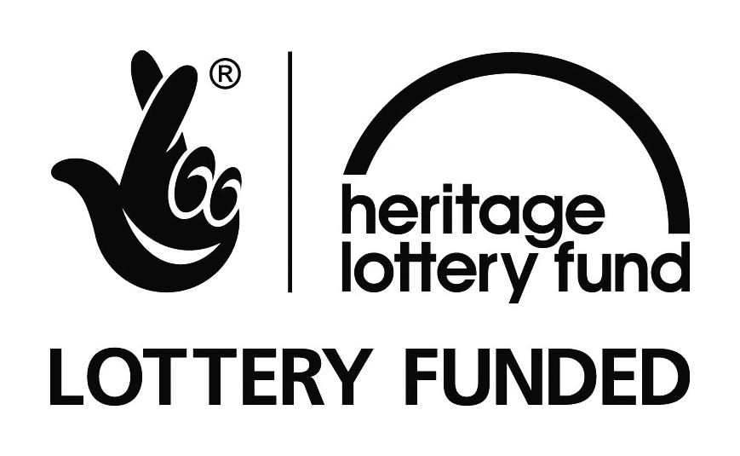

NOTES TO EDITORS
The Peatlands Partnership includes Scottish Natural Heritage, Forestry Commission Scotland Council, RSPB Scotland, Plantlife Scotland, Highlands & Islands Enterprise, The Highland Third Sector Interface, The Flow Country Rivers Trust, The Northern Deer Management Group and The Environmental Research Institute. It is chaired by Professor Stuart Gibb from the Environmental Research Institute.
RSPB Scotland is the lead partner in The Flows to the Future project, a Peatlands Partnership project, which gratefully acknowledges funding from the Heritage Lottery Fund and from the following funders and supporters; Environmental Research Institute, European Regional Development Fund, Forestry Commission (Scotland), Peatland Action, Highlands and Islands Enterprise, The Highland Council, RSPB, WREN, Scotland Rural Development Programme, Scottish Government, Scottish Natural Heritage and The Tubney Trust.

CONTACT DETAILS
Caroline Eccles Project Manager - Flows to the Future Project, working on behalf of The Peatlands Partnership, c/o The Flows Field Centre, Forsinard Mobile 07590 441475 or caroline.eccles@rspb.org.uk
Ian Mitchell, Secretary, The Peatlands Partnership, c/o Scottish Natural Heritage: Tel 01408 634063 or peatlands_partnership@snh.gov.uk

