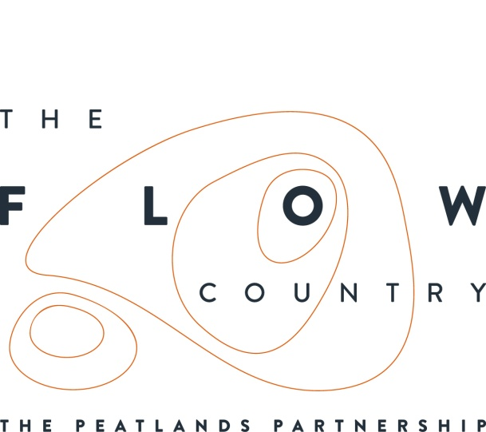

May 2018
Flow Country in the Limelight

During the launch of his new book in Edinburgh this weekend, renowned UK nature writer Mark Cocker proclaimed The Flow Country of Sutherland and Caithness to be “arguably the most important landscape in Britain and certainly, in world terms, the rarest habitat for which we have responsibility”.

His new book, “Our Place” looks at the history of the environmental movement in the UK through Cocker’s own journeys to six landscapes that have been pivotal in that story. It also raises concerns about the state of the countryside and questions why there has been such a decline in nature in recent decades when we are apparently a nation of nature lovers.

The launch took place during the Royal Botanic Garden Edinburgh’s Connect with Nature writing festival, with a conversation between Cocker and Caroline Eccles, Project Manager for the Flows to the Future Project in the Flow Country. Inevitably, much of the conversation was about the landscape of The Flow Country.

Cocker notes in his book that “Visually the land can appear bleak and uninviting…(but) bog is made truly captivating if you understand a little of the processes that are locked away beneath its surface modulations… It might appear bleak or desolate, but the whole thing is a living and breathing mechanism.”

The importance of the Flow Country comes both from the crucial role of the peat as a carbon store (as well as a record of the past), and from its international importance for both habitats and species, especially moorland bird populations. Despite the area’s clear significance, Cocker also suggests that the fact that the Flow Country still hasn’t been put forward for nomination as a World Heritage Site indicates suggest an apparent lack of pride in the area.

Cocker also stresses the importance of the landscape for less tangible reasons,

“What gives value to this place is precisely its inhumanity, its resistance to all that we are… In this small island of too many people there should have been one last brown god – a land of Sphagnum and water and wind and birdsong that we had not mastered.”

The book also explores – as did the conversation – the challenges the landscape has faced, particularly with the planting of large areas of deep peat in the 1980s. Cocker gave due praise to both the RSPB and the Nature Conservancy Council (now Scottish Natural Heritage) for their stand at the time to ensure more peatland did not go under the plough but also for the on-going efforts to restore peatland by removing forestry.

An exhibition about The Flow Country is currently touring Scotland and is now at Low Park Museum in Hamilton. More details can be found on www.theflowcountry.org.uk

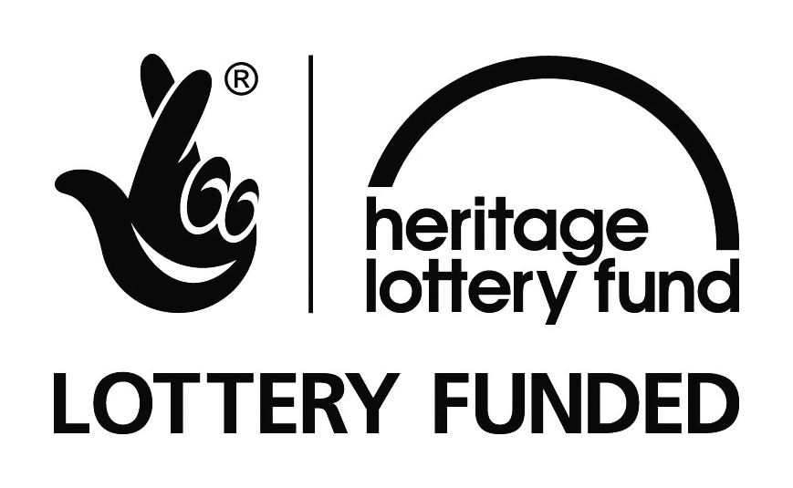

Photographs:
Caroline Eccles, Flows to the Future Project Manager and Mark Cocker in conversation.
The Flows Lookout and bog pools at Forsinard, Sutherland (credit Neil Cowie RSPB)
NOTES TO EDITORS
RSPB Scotland is the lead partner in The Flows to the Future project, a Peatlands Partnership project, which gratefully acknowledges funding from the Heritage Lottery Fund and from the following funders and supporters; Environmental Research Institute, European Regional Development Fund, Forestry Commission (Scotland), Peatland Action, Highlands and Islands Enterprise, The Highland Council, RSPB, WREN, Scotland Rural Development Programme, Scottish Government, Scottish Natural Heritage and The Tubney Trust.

The Peatlands Partnership includes Scottish Natural Heritage, Forestry Commission (Scotland), Highland Council, RSPB Scotland, Plantlife Scotland, Highlands & Islands Enterprise, The Highland Third Sector Interface, The Flow Country Rivers Trust, The Northern Deer Management Group and The Environmental Research Institute. It is chaired by Professor Stuart Gibb from the Environmental Research Institute, University of the Highlands and Islands.
MARK COCKER is an author of creative non-fiction. He is also a naturalist and environmental tutor, who writes and broadcasts on nature and wildlife in a variety of national media. He has just released his new book Our Place (Cape) on the fate of British nature since the beginning of the twentieth century. He will also complete 30 years as a Guardian country diarist in 2018.
His 10 other books include works of biography, history, literary criticism and memoir. They include Claxton: Field Notes from a Small Planet (2014) and Birds and People (2013). The latter was published to international acclaim and was a collaboration with the photographer David Tipling. Between them these two were shortlisted for six literary awards including the Thwaites/Wain- wright Prize. His book Crow Country was shorlisted for several awards, including the Samuel Johnson Prize, and won the New Angle Prize (2009). In 2016 he was awarded an Honorary Doctorate of Literature from the University of East Anglia, where he has recently placed his archive.
.

CONTACT DETAILS
Caroline Eccles Project Manager - Flows to the Future Project, working on behalf of The Peatlands Partnership, c/o North Scotland Regional Office, Inverness. 01463 715000, Mobile 07590 441475 or caroline.eccles@rspb.org.uk
Ian Mitchell, Secretary, The Peatlands Partnership, c/o Scottish Natural Heritage: Tel 01408 634063 or peatlands_partnership@snh.gov.uk

