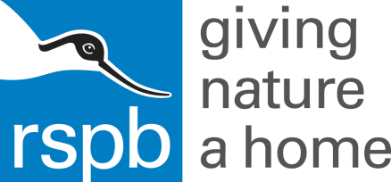

Media release
Date: 2017

Conservationists seek support for Sutherland peatland restoration funding bid
RSPB Scotland’s objective to remove conifer plantation and restore Flow Country will be decided by public vote
RSPB Scotland is asking for public support to secure funding from the European Outdoor Conservation Association (EOCA) to restore an important site in the Flow Country, the Dyke plantation near Forsinard in Sutherland.
The project is one of five nature projects in the running for EOCA funding, with the final decision being made by public vote between 9th and 23rd March on the EOCA website.
The Dyke plantation was planted with non-native sitka spruce and lodgepole pine trees some thirty years ago and the trees have caused significant damage to the peatlands on which it was planted, and which forms part of the internationally important Flow Country, Europe’s largest raised blanket bog.
Should the peatland restoration project gain the most votes the funding from EOCA will contribute to a programme of work being delivered by the Peatlands Partnership through its Flows to the Future programme.
George Campbell of RSPB Scotland said, “The Flow Country is of European significance and it seems appropriate to make a bid on behalf of the Flow Country to the European Outdoor Conservation Association. I very much hope that the public will share our view that this precious part of Scotland’s natural heritage is well worth supporting and cast their vote for this peatland restoration project.”

Mr Campbell explained that RSPB Scotland has an established track record of restoring damaged peatlands in the Flow Country and, with a number of academic partners, is researching the best ways of working to ensure the money goes as far as possible.
“The results of our work are constantly monitored to ensure that the techniques of tree removal and peatland restoration we choose have the maximum possible impact. The use of drain-blocking is particularly important in restoring the water table and encouraging the characteristic plants of the Flow Country to re-colonise the cleared areas.”
Mr Campbell added, “The work will be undertaken by local contractors and should contribute to the local economy as does all the peatland restoration that is taking place under the auspices of the Flows to the Future project.”
RSPB Scotland hopes that local people will help secure the funding by voting for the proposal online at: http://bit.ly/1eUMGSu
It is possible to vote between 9th March and 23rd March.

For further information and to arrange an interview, please contact:

Public Affairs Manager Alan Tissiman on 01463 228810 (mobile: 07775 227614) or alan.tissiman@rspb.org.uk

Photographs:

Editor’s notes:
1. The RSPB is the UK’s largest nature conservation charity, inspiring everyone to give nature a home. Together with our partners, we protect threatened birds and wildlife so our towns, coast and countryside will teem with life once again. We play a leading role in BirdLife International, a worldwide partnership of nature conservation organisations.

The Royal Society for the Protection of Birds
North Scotland Region
Etive House, Beechwood Park, Inverness, IV2 3BW
Telephone: 01463 715000
Email: nsro@rspb.org.uk

The Royal Society for the Protection of Birds (RSPB) is a registered charity.
In England and Wales, no: 207076.
In Scotland, no: SC037654.

