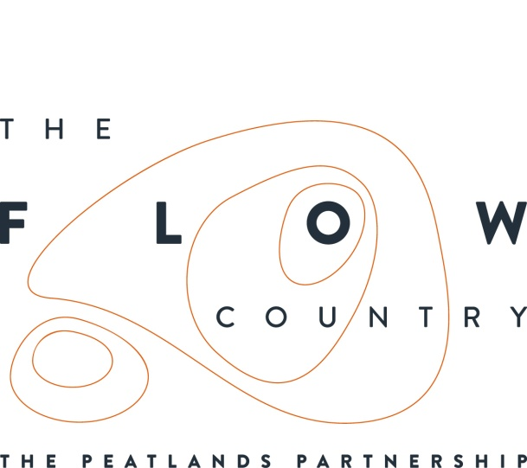

Press Release: 15/08/17

Natural Food and Fabulous Music at RSPB Forsinard Flows National Nature Reserve

On Wednesday 9 August over 70 people attended an event at RSPB Scotland’s Forsinard Flows visitor centre, where young musicians from the Fèis Rois Ceilidh Trail played and Scotland’s Natural Larder provided delicious natural wild food.

The event allowed visitors to discover the new interpretation at the Forsinard visitor centre while experiencing some exceptional Scottish music. Visitors later walked out to the Flows Lookout tower on the nature reserve’s Dubh-Lochain trail, again to listen to the music. Both the interpretation and tower were developed as part of the Heritage Lottery funded “Flows to the Future” project. The project is working to restore the peatlands of the Flow Country and enable people to find out more about peatlands and the important role they play in mitigating against climate change.

The Fèis Rois is a leading traditional arts organisation based in Dingwall, and their Ceilidh Trail project employs outstanding young musicians to perform Scottish music throughout the country. This informal concert was part of their summer touring schedule of National Nature Reserves across Scotland and was sponsored by Scottish Natural Heritage.

Outside the visitor centre Scotland’s Natural Larder, a project initiated by Scottish Natural Heritage, provided visitors with the opportunity to taste freshly made wild garlic pesto on oatcakes and venison chilli, among other samples.

They also had a range of postcard recipes for visitors to take away, explaining how to make sugar-kelp crisps, nettle pesto, and more. Scottish Natural Larder encourages people to reconnect with local natural produce that has been harvested or hunted. It also encourages responsible use of our rich natural food resources.

Ian Mitchell, an Operations Officer with SNH said; “Forsinard had quite a week last week! On Monday Roseanna Cunningham MSP visited the area to look at the work of the Peatlands Partnership and open the new Flows Field Centre and on Wednesday, there was this excellent Fèis Rois Ceilidh Trail and Scotland’s Natural Larder event on one of Scotland’s great National Nature Reserves. Well done to all those who helped deliver such a feast for all the senses!”

Jacqueline Mainprize, a visitor to the event, said; “The music and food were fantastic. There was a wonderful atmosphere and it was great to experience the nature reserve alongside traditional music and natural food.”

For details about future events and to find out more about peatlands visit the Flow Country website www.theflowcountry.org.uk, or find the Flow Country on facebook and on twitter.

The Flows to the Future project would like to thank Scottish Natural Heritage for funding the event.

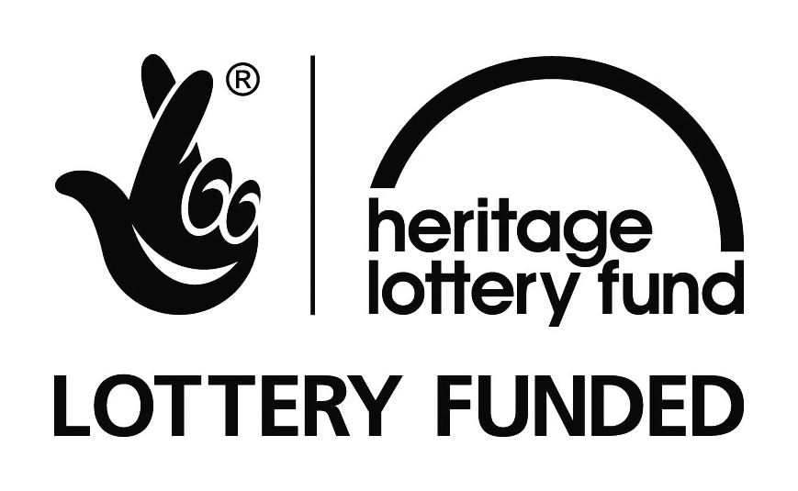

Photograph:
Feis Rois playing at the Forsinard Lookout Tower – Copyright Kevin Arrowsmith
Scottish Natural Larder serving up natural food – Copyright Kevin Arrowsmith
The Lookout Tower at RSPB Scotland’s Forsinard Flows National Nature Reserve – Copyright Kevin Arrowsmith

CONTACT DETAILS
Alan Tissiman RSPB Public Affairs Manager can be contacted on 01463 228810 or 07775 227614 or alan.tissiman@rspb.org.uk
Caroline Eccles Project Manager - Flows to the Future Project, working on behalf of The Peatlands Partnership, c/o North Scotland Regional Office, Inverness. 01463 715000, Mobile 07590 441475 or caroline.eccles@rspb.org.uk
Ian Mitchell, Secretary, The Peatlands Partnership, c/o Scottish Natural Heritage: Tel 01408 634063 or peatlands_partnership@snh.gov.uk
Notes for Editors:

THE PEATLANDS PARTNERSHIP includes Scottish Natural Heritage, RSPB Scotland, The Highland Council, The Environmental Research Institute (University of the Highlands and Islands), Forestry Commission (Scotland), Plantlife International, Highland Third Sector Interface, the Flow Country Rivers Trust, Northern Deer Management Group and Highlands and Islands Enterprise. It is chaired by Professor Stuart Gibb of the Environmental Research Institute/University of the Highlands and Islands.

The Peatlands Partnership was formed at the end of 2006 following the completion of the EU LIFE funded Peatlands Project and aims to develop and build on that project. The Partnership comprises 'core' organisations, together with other interested organisations and individuals, who will carry out and support the objectives set out in the Management Strategy document, 'The Peatlands of Caithness and Sutherland'.

The Partnership operates over the whole of Sutherland and Caithness and includes the internationally important blanket bog area known as The Flow Country.
The current activities of the Partnership include:
- Delivering the Flows to the Future project,
- Revision of the Peatlands Management Strategy,
- Acting as a forum for discussing issues relating to peatlands and peatland management, and
- Taking forward the possible UNECSO inscription of The Flow Country as a World Heritage Site.

The Flow Country
The Flow Country is an area of deep peat, dotted with bog pools, that blankets much of Caithness and Sutherland. The Flow Country is the largest expanse of blanket bog in Europe and covers about 200,000 hectares. A recent academic study has described The Flow Country as being “the best peatland of its type in the world”. The Flow Country is on the UK’s tentative list for potential UNESCO World Heritage Sites.

Blanket bog only forms in cool places with plenty of rain. The few plants that can grow here such as bog mosses, don’t rot away, but build up to form deep layers of peat. The Flow Country’s bogs have been growing for over 10,000 years, ever since the glaciers melted away at the end of the last Ice Age, and the peat is now over 10 metres deep in places.

This accumulated peat importantly stores about 400 million tonnes of carbon. Only active healthy bogs can lock up carbon in peat and so many areas damaged in the past by inappropriate land management such as commercial afforestation are now being restored back to healthy bog habitat.

The Flow Country is also internationally important as a breeding ground for birds that depend on this wild, unspoilt environment. Red-throated and black-throated divers, golden plover and greenshank nest here, while raptors like merlin, short-eared owls and golden eagles hunt over the moss and pools.

These sorts of benefits or “ecosystem services” are increasingly recognised as major contributions to the economy, and they extend beyond protecting the environment and creating valuable economic resources.
Thousands of people come to The Flow Country every year not because of its role as a defence against climate change or because it maintains good water quality, but because it offers a rare experience of wilderness, solitude and inspiration. In the words of a Scottish Government briefing paper, peatlands give us ecosystem services that “contribute to making human life both possible and worth living.”

FLOWS TO THE FUTURE is a far reaching and ambitious project which aims to significantly increase the level of conservation management and promotional activities currently being undertaken in the Flow Country.
The £10.6 million project, with over £4 million of support from the Heritage Lottery Fund, is aiming to restore areas of blanket bog in the heart of the Flow Country that have been damaged by forestry planting. It will also promote and develop our knowledge about the role of peat and carbon storage, and involve and connect people everywhere with this precious habitat, delivering real economic benefits for one of the least densely populated areas in Scotland.

The project started on 4 July 2014 and will continue over 5 years. It is being delivered by a core Steering Group of Peatland Partnership members – Highland Council, Scottish Natural Heritage, Environmental Research Institute (UHI), and with RSPB (Scotland) as the lead partner.

Project outputs, in addition to the building of the new Flows Field Centre include the following:

- The project is restoring 7 square miles of blanket bog habitat – removing forestry blocks, crushing brash and blocking furrows in areas where forestry has already been felled, and drain blocking, on RSPB Forsinard Flows National Nature Reserve (NNR).

- We are developing five roadside interpretation sites across the Flow Country to give panoramic views of the peatlands and provide a trail for visitors and local people to experience and learn about the peatlands.

- The project has updated and improved the visitor centre at Forsinard Flows NNR and is providing improved parking and upgraded interpretation on the NNR’s Dubh Lochan Trail.

- The project will be creating improved and increased access for walkers as well as developing novel and innovative interpretation and learning opportunities for people across the Flow Country.

- We have developed a successful schools’ learning programme and a 5 year programme of community activities both at Forsinard and throughout Caithness and Sutherland.

- We have created a 6m high viewing tower – the architectural award winning “Flows Lookout” – and an easy access boardwalk along a Dubh Lochan Trail at Forsinard.

- For those unable to visit the Flow Country the project has developed remote learning and awareness raising opportunities through; an interactive website, a documentary film, an online 3D landscape model of the Flow Country and an exciting carbon capture computer game.

- To engage with new audiences we have developed some creative community arts commissions to encourage people to engage with the Flows through the arts.

- A UK wide travelling exhibition about carbon and peatlands was launched by The Peatlands Partnership at the Royal Botanic Gardens in Edinburgh in June.

