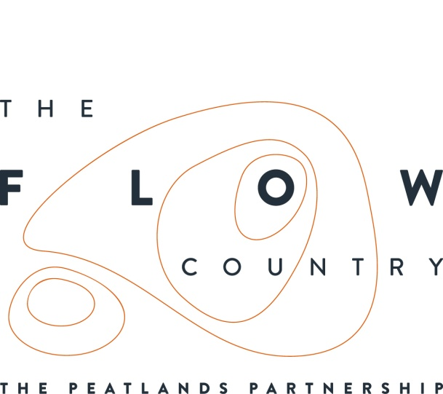

Press Release: 23 March 2017 FOR IMMEDIATE USE

Wintery fact finding mission
Local MP Dr Paul Monaghan visited Forsinard in the heart of The Flow Country recently to learn about the important work being carried out there at the moment.

Dr Monaghan braved the wintery conditions to visit the Flows Lookout, which gives impressive views over peatland pools and towards the Ben Griams, and also toured the new Flows Field Centre.

He was particularly interested to find out more about the international significance of the Flow Country and why areas of forest are being restored to open peatland as part of the Peatland Partnership’s Heritage Lottery funded ‘Flows to the Future Project’.

Dr Monaghan commented:

“I was most impressed to hear about the work being undertaken in partnership at Forsinard and the benefits this is bringing to the local economy through the work of contractors and by improving facilities for tourism across The Flow Country.”

Dr Monaghan was also interested to hear about the uses that the new field centre is being put to. In recent weeks it has hosted postgraduate students from the Edinburgh College of Art and researchers from a range of universities and institutions who are looking at the role bogs play in mitigating against climate change. All these visitors are helping to put the Flow Country on the map.

He was accompanied on his visit by Dr Andrew Coupar, Uplands and Peatlands Policy Advice Manager for Scottish Natural Heritage, Graham Thompson, Site Manager for RSPB Forsinard Flows and Caroline Eccles, Project Manager for the Flows to the Future Project.

Photos: Three photos provided which show Dr Paul Monaghan MP, Dr Andrew Coupar, Uplands and Peatlands Policy Advice Manager for Scottish Natural Heritage and Caroline Eccles, Project Manager for the Flows to the Future Project (each photo labelled to give left to right names) on the visit to the Flows Lookout at Forsinard.

NOTES TO EDITORS
The Peatlands Partnership includes Scottish Natural Heritage, Forestry Commission (Scotland), Highland Council, RSPB Scotland, Plantlife Scotland, Highlands & Islands Enterprise, The Highland Third Sector Interface, The Flow Country Rivers Trust, The Northern Deer Management Group and The Environmental Research Institute.. It is chaired by Professor Stuart Gibb of the Environmental Research Institute (North Highland College ERI).
RSPB Scotland is the lead partner in The Flows to the Future project, a Peatlands Partnership project, which gratefully acknowledges funding from the Heritage Lottery Fund and from the following funders and supporters; Environmental Research Institute, European Regional Development Fund, Forestry Commission (Scotland), Peatland Action, Highlands and Islands Enterprise, The Highland Council, RSPB, WREN, Scotland Rural Development Programme, Scottish Government, Scottish Natural Heritage and The Tubney Trust.

CONTACT DETAILS
Alan Tissiman RSPB Public Affairs Manager can be contacted on 01463 228810 or 07775 227614 or alan.tissiman@rspb.org.uk
Caroline Eccles Project Manager - Flows to the Future Project, working on behalf of The Peatlands Partnership, c/o North Scotland Regional Office, Inverness. 01463 715000, Mobile 07590 441475 or caroline.eccles@rspb.org.uk
Ian Mitchell, Secretary, The Peatlands Partnership, c/o Scottish Natural Heritage: Tel 01408 634063 or peatlands_partnership@snh.gov.uk

