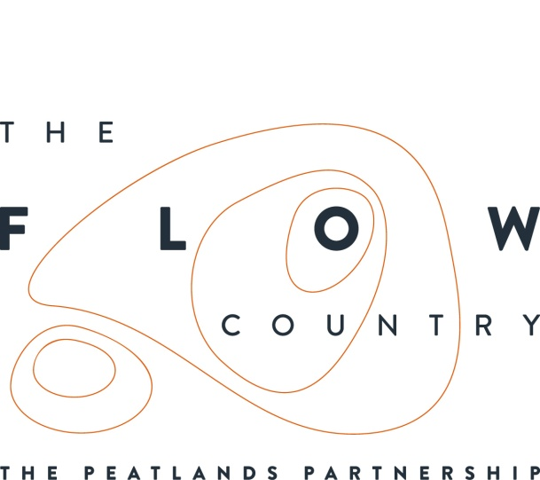

Press Release: 8 January 2018 for immediate use

The Flows inspires Edinburgh College of Art students

The Flow Country has long been a magnet for artists and writers, drawing inspiration from the flora and fauna and the unseen magic and history locked away in the peat.
An exhibition of artwork inspired by the Flow Country has recently been held in Edinburgh, following a visit to Forsinard in October by postgraduate students. This was the second group of Master of Arts and Master of Fine Arts students to visit from the Art Space and Nature course at the Edinburgh College of Art. The students come from across the world, including China, Chile, Singapore, Canada, the United States and the UK . The unique landscape of the Flows was their destination, and starting point for creating new site-specific work.
The six students spent just under a week staying at the Flows Field Centre in Forsinard, exploring the environment and learning about the important restoration work that is taking place. They met with Flows to the Future and RSPB Scotland staff working at Forsinard, as well as spending time with local poet and writer George Gunn.
The exhibition at the Tent gallery in Edinburgh was entitled ‘decompose/ recompose’. The students introduced the exhibition as being “Further explorations of the Scottish Highlands / De-composing our understanding of this environment/ Manipulating organic and inorganic elements / Re-composing them into new experiences / Bringing forward alternative perspectives.”
One particular piece of work in the exhibition by Cody Lukas Anderson brought actual peat into the gallery. Entitled: On Loan, 55°48 58.2 N 3°31 09.5 W, the work consists of twelve square sections of peatland landscape suspended within the gallery, on loan from near Edinburgh to where they have now been returned.. Cody commented that “their presence here in the space comes at the cost of their absence from the landscape”. The exhibit encouraged people to think about the importance of peat in the landscape and also the diversity which can be seen if you look close up at just a small area.
Another series of works entitled Non-Human Architecture created by Chilean student Luiz Guzman refers to organic forms and biological processes within the structure of the bog. He transforms these ideas into architectural sculpture, which questions the idea of human space and the advance of technology.
The exhibition was the second in a series of outputs generated from the field trip to the Flow Country, the first being an exhibition of initial responses. The next task will be for the students to use the setting at Forsinard to develop speculative and site specific proposals for public art.

Donald Urquhart, programme director of the Art, Space and Nature course commented “The Flow Country is proving to be a rich source of inspiration for the students and we are delighted to be working in partnership with The Flows To the Future Project, the ability to take students out into the landscape and give them the time to absorb and then respond to the area will have been an invaluable experience for all involved.
There is no doubt that the work that has been created encourages the viewer to look closer, and think about the peatlands in new ways and in particular think about the importance of The Flow Country in the context of global climate change. “

The Flows To The Future project continues to work with artists and creative practitioners, 2018 will bring events in Caithness and Sutherland and an exhibition from commissioned artists, Shaun Fraser and Hannah Imlach.

Exhibition photo numbers and captions.

Photo ED3 = Luis Guzman - Non-Human Architecture – Tent gallery, Edinburgh. Photograph by:
Photo ED7 = Cody Lukas Anderson - On Loan, 55°48 58.2 N 3°31 09.5 W - Tent Gallery, Edinburgh. Photograph by:
Photo ASN2 = Artists Group Photograph featuring ?????? -Tent Gallery, Edinburgh. Photograph by:

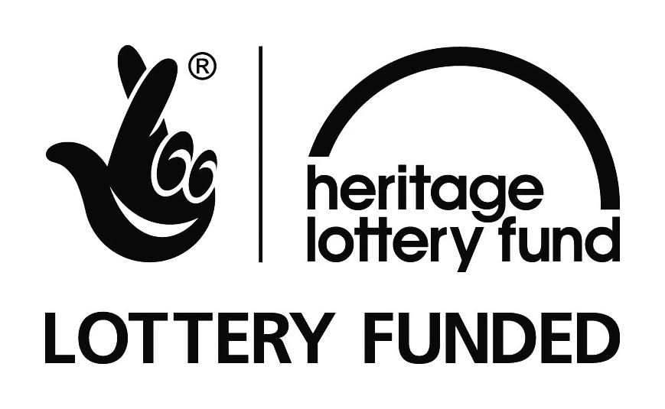

NOTES TO EDITORS
The Peatlands Partnership includes Scottish Natural Heritage, Forestry Commission Scotlandland Council, RSPB Scotland, Plantlife Scotland, Highlands & Islands Enterprise, The Highland Third Sector Interface, The Flow Country Rivers Trust, The Northern Deer Management Group and The Environmental Research Institute. It is chaired by Professor Stuart Gibb from the Environmental Research Institute.
RSPB Scotland is the lead partner in The Flows to the Future project, a Peatlands Partnership project, which gratefully acknowledges funding from the Heritage Lottery Fund and from the following funders and supporters; Environmental Research Institute, European Regional Development Fund, Forestry Commission (Scotland), Peatland Action, Highlands and Islands Enterprise, The Highland Council, RSPB, WREN, Scotland Rural Development Programme, Scottish Government, Scottish Natural Heritage and The Tubney Trust.

CONTACT DETAILS
Caroline Eccles Project Manager - Flows to the Future Project, working on behalf of The Peatlands Partnership, c/o The Flows Field Centre, Forsinard Mobile 07590 441475 or caroline.eccles@rspb.org.uk
Ian Mitchell, Secretary, The Peatlands Partnership, c/o Scottish Natural Heritage: Tel 01408 634063 or peatlands_partnership@snh.gov.uk

